Purpose
To give clear expectations and a process on what is required when a staff member or a close contact of theirs has been tested for COVID-19.

Scope
The procedure applies to all Melbourne Water employees and contractors.

Scenario Selection Flow Chart
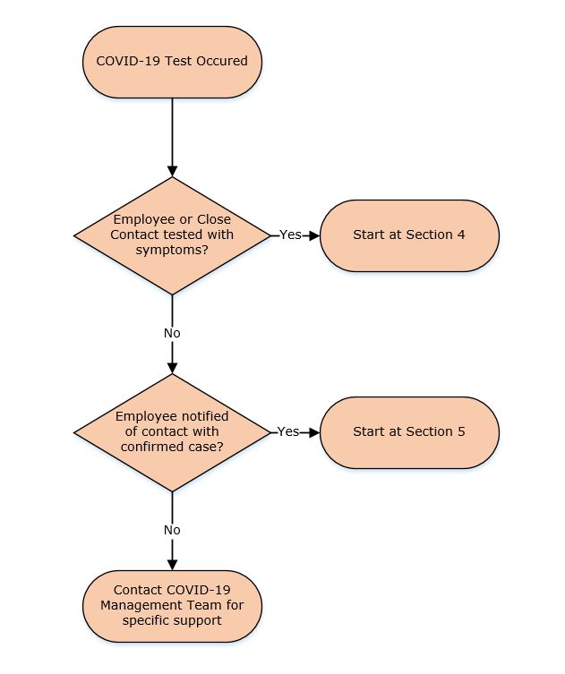

Tested Due To Symptoms
This process must be followed when an employee or a close contact of theirs has been tested because they have COVID-19 symptoms.
Step | Responsibility | Action
1 | Employee | Notify Manager that COVID test is being conducted by DHHS approved testing facility on themselves or close contact.
2 | Manager | Notify Employee to self-isolate at home until further notice.
3 | Employee | Notify Manager of test results regardless of the outcome.
4 | Manager | - If results are negative – Inform employee to recommence normal work arrangements.  - If close contact results are positive – Follow: Section 5 – Notified of Contact with Confirmed Case  - If employee results are positive – Follow: Section 6 – Positive COVID-19 Test Result.

Notified Of Contact With Confirmed Case
This process must be followed when an employee has been told that they have been in close contact with someone that’s confirmed to have COVID-19.
Step | Responsibility | Action
1 | Employee | Notify Manager of close contact with person that is confirmed to have COVID-19.
2 | Employee | Self-quarantine at home. DHHS will provide advice on testing and isolation requirements.
3 | Manager | Email COVID-19 Inbox with latest information.
4 | Manager and Employee | For the period of 48 hours since last known contact with confirmed COVID-19 case, gather a list of work related:  - People who have been within 1.5 metres for more than 15 minutes and/or  - People who have worked in close proximity for more than two hours and;  - Work locations that the employee has visited in this period.
5 | Manager | Shares work related Contact Tracing list with COVID-19 Management Team.
6 | Manager | Further segregate identified close contacts of employee while awaiting test results or until 14 days of last known contact has passed.
7 | COVID-19 Management Team | If there are 3 or more suspected cases within a 5-day period complete a DHHS risk assessment.
8 | Employee | Notify Manager with updated information from DHHS regarding testing and isolation clearance requirements.
9 | Manager | Provide regular updates on situation to the COVID-19 Management Team.  Then follow: Section 7 – Return to Work after COVID-19

Positive COVID-19 Test Result
This process must be followed when an employee has had confirmation that they have COVID-19. This should generally follow on from Sections 4 and 5.
Step | Responsibility | Action
1 | Employee | Self-isolate at home and liaise with DHHS.
2 | Employee | Notify Manager if not already done so.
3 | Manager | Seek approval from employee that case details can be shared confidentially for Contact Tracing purposes.  Contact COVID-19 Management Team as soon as possible.
4 | COVID-19 Management Team | If additional resources are required – Consider whether case specific incident team should be stood up to manage active case and potential further cases and conduct a DHHS risk assessment.
5 | COVID-19 Management Team | Immediately contact:  - The DELWP Water Duty Officer and open communication channel for updates as required  - WorkSafe via their COVID-19 incident notification portal.
6 | Manager and Employee | If not already completed:  For the period of 48 hours prior to the test, or when they began showing symptoms gather a list of work related:  - People who have been within 1.5 metres for more than 15 minutes throughout one day and/or  - People who have worked in close proximity for more than two hours throughout one day and;  - Work locations that the employee has visited in this period.
7 | Manager | Share the following with the COVID-19 Management Team:  - Staff Contact Tracing list  - Prioritised list of sites which require deep cleaning  Reprioritise work at these locations until deep clean has been completed.
8 | COVID-19 Management Team | Contact Managers of employees identified on the Contact Tracing list and tell them to follow: Section 5 – Notified Of Contact With Confirmed Case.
9 | COVID-19 Management Team and Managers | As per: Section 10 – Site Containment and Cleaning:  - Arrange for containment and cleaning to be carried out at required sites.  - Restrict access to these sites until deep cleaning is completed.
10 | COVID-19 Management Team | If required:  - adjust appropriate internal communication message to match specific circumstances of positive case.  - prepare media points and liaise with DELWP.
11 | Manager | Continue to liaise with Employee and COVID-19 Management Team.
12 | COVID-19 Management Team | Report back to Leadership Team as required on current situation.
13 | COVID-19 Management Team | Liaise with employee’s Manager regarding site action progress.
14 | Employee | Continues to self-isolate until clearance is given by DHHS.  Then follow: Section 7 – Return to Work after COVID-19.

Return to Work after COVID-19
This process must be followed when an employee has been in self-isolation due to a positive COVID-19 test or in close contact with someone who has had COVID-19.
Step | Responsibility | Action
1 | Employee | Receives notification from DHHS that they no longer need to isolate.
2 | Employee | Contacts Manager to confirm that they have clearance to return to work.
3 | Manager | - Informs Employee to continue to isolate while a return to work date is agreed upon.  - Contacts COVID-19 Management Team to confirm that the Employee has clearance to return to work.
4 | COVID-19 Management Team and Manager | Agree on return to work date and plan considering the following:  - Date that clearance was given to the employee.  - Type of work that the employee needs to return to.  - The mental health of the employee and appropriate speed of return.  - Communication with employee’s team that there is no increased risk of COVID-19 due to their return.  Potential increased support required to employee’s family due to any ongoing isolation should be considered. E.g. Family still in isolation.
5 | Manager and Employee | Implement agreed return to work plan.

Leave Types
Leave Type | Definition
COVID-19 Self Quarantine Leave | When a healthy employee has to self-quarantine and is unable to work from home (e.g. Operators):  - because they or a household member are awaiting COVID-19 test results or;  - are in travel quarantine or;  - you’ve been identified as a COVID-19 close contact by DHHS.
COVID-19 Sick Leave | For when an employee is confirmed to have COVID-19 and they are unable to work due to illness.
COVID-19 Carers Leave | When a healthy employee has to care for a family member with COVID-19.
Sick Leave | Leave for when an employee is sick and unable to work.
Carers Leave | Leave for when a healthy employee is unable to work as they are caring for a family member.

Permitted Workers
This is only required when the Permitted Worker Scheme is in effect:
Permit Type
Permitted Workers Permit | For employees that are required to attend site to complete essential work.
Permitted Workers Permit (including Childcare) | For employees that are required to attend site to complete essential work and need to put kids in childcare.

If an employee meets the requirements of any of the above permit types, follow this process:
Step | Responsibility | Action
1 | Manager and Employee | Discuss potential flexible work arrangements (include P&C if necessary). If this is not possible, select appropriate Permit from the above list.
2 | Manager (or GM) | Sign Permit and include contact details at the bottom of form. Send copy to employee and COVID-19 Mailbox.
3 | Employee | Keep the Permit and identification with you when travelling to and from work or childcare facilities.

Site Containment and Cleaning
Any sites/areas that have had an employee or contractor who had been confirmed to have COVID-19 must follow this process.
Step | Responsibility | Action
1 | Manager | If not already completed, notify COVID-19 Management Team of situation.
2 | Manager | - Share prioritised list of sites and specific areas that require deep cleaning with COVID-19 Management Team.  - Safely stop ongoing work at these sites.  - Reschedule any upcoming work within identified cleaning boundary.  - Make it clear that site access is restricted until further notice with signage and barriers.
3 | COVID-19 Management Team | Contacts a COVID-19 Cleaning Crew Manager:  Consolidated Property Services (CPS)  - Tatiana Colobon 0455 507 725  - Douglas Rengifo 0448 999 392  - George Soumelidis 0409 184 206  Spree Enterprises PTY Ltd  - Frank Lombardo 0432 210 031 or 03 9100 0605  Biohazmat Pty Ltd  - Josh Marsden 0478 074 020 or 1300 246 429
4 | COVID-19 Management Team | Allocates SHEQ Manager to be the Site Manager during cleaning phase and communicates this with Manager.
5 | SHEQ Manager | Takes on role as Site Manager and:  - Attends site to preserve and restrict site access.  - Provides site induction for COVID-19 Cleaning Crew.  - Directs Cleaning Crew on areas to be deep cleaned.
6 | SHEQ Manager | Stay in contact and take direction from COVID-19 Management Team.
7 | COVID-19 Cleaning Crew | Undertakes deep cleaning of areas as directed by SHEQ manager in accordance with Cleaning and disinfection principles for COVID-19.
8 | SHEQ Manager | Once site cleaning is completed, communicate this to COVID-19 Management Team.
9 | SHEQ Manager & COVID-19 Cleaning Crew | Move to next site and repeat steps 5-8 until all sites designated for cleaning have been deep cleaned.
10 | SHEQ Manager | Reports that all deep cleaning has been completed to COVID-19 Management Team.
11 | COVID-19 Management Team | Requests clearance from DHHS that the workplace can reopen. Once approved, provides clearance to Manager that all site access can be reinstated.

Responsibilities
Role | Responsibility
Manager | - Ensure the wellbeing of impacted team members is prioritised.  - Be the liaison between the COVID-19 Management Team and impacted employees.
COVID-19 Management Team | - Monitor ongoing COVID-19 Pandemic situation.  - Monitor COVID-19 inbox.  - Centrally control incident when outbreak occurs.  - Centrally control deep cleaning and reinstate site access.
Employee | - Log close contact and locations worked each day.  - Contact Manager as soon as they are tested for COVID-19.  - Maintain physical distancing and high hygiene standards.
SHEQ Manager | - Maintain communication between all parties throughout the pandemic.  - Take on the responsibility of Site Manager during the deep cleaning process.

Definitions
Reference | Definition
Close Contact | A person has been in close contact when throughout one day:  - They spent more than 15 minutes face-to-face with someone who is a suspected or confirmed case and while they were infectious.  - They have shared a closed space for more than two hours with someone who is a suspected or confirmed case and while they were infectious.  Examples include:  - Sharing a vehicle for more than 15 minutes.  - Working in an enclosed space like a small office or lab.  - Working closely on the same piece of equipment where the same surfaces are frequently touched.  - A member of your household.
Infectious | A person with COVID-19 is infectious 48 hours prior to the onset of symptoms and until they meet DHHS criteria for release from isolation.

References
Document title
DHHS Close Contact Fact Sheet
DHHS Confirmed Case Fact Sheet
DHHS Self-Assessment Tool
Safe Work Australia – COVID-19 Cleaning Table
Cleaning and disinfection principles for COVID-19

Document History
Date | Reviewed/  Actioned By | Version | Action
May 2021 | COVID-19 Manager | 4 | Removed section redundant section regarding being tested with no symptoms with changes to DHHS guidelines.
Oct 2020 | COVID-19 Manager | 3 | Various sections updated to align with updated DHHS guidelines.

