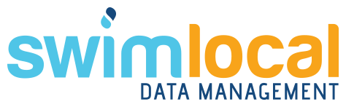

SWIM*Local* User Manual

Version 2.1: Annual Data

SWIMLocal

Annual Data



SWIMLocal

Admin



SWIMLocal

Operations



SWIMLocal

Reports



June 2018

***qldwater***

STATEWIDE WATER INFORMATION MANAGEMENT SYSTEM

[www.qldwater.com.au/swim](http://www.qldwater.com.au/swim)



Contents

SWIM*Local* Admin tool 3

Login screen 3

Home screen 3

Manage SWIM*Local* users 4

Adding/editing a user 4

Common alert/error messages during user login 10

SWIM*Local* Annual Data Tool 11

Login screen 11

Home screen (data entry) 11

File tab (export, print, sync) 13

Edit tab (find function) 13

Help tab 14

Filtering indicators 14

Save button 16

Reset button 16

Mouse (cursor) hover-over functionality 16

Missing data (MD) 17

Not relevant (NR) indictors 17

Calculated indicators 17

Invalid/error values 18

Yellow highlighted ‘invalid’ cells 19

Red highlighted ‘error’ cells 19

Adding a comment to a data point 20

Publishing data 21

# SWIM*Local* Admin tool

Each WSP will need to have at least one SWIM*Local* administrator who has access to all the WSP data and is responsible for administering SWIM*Local* metadata and managing user accounts (recommended two to cover for absentees). The admin tool contains the following screens to manage user accounts and metadata for indicator and task (when appropriate) data entry/reporting:

* Category list
* Indicator list
* Schemes
* Sites
* Task categories
* Task priorities
* Task roles
* Tasks
* Annual data access group
* Operations access group
* SWIM*Local* users

These screens are explained in more detail below.

## Login screen

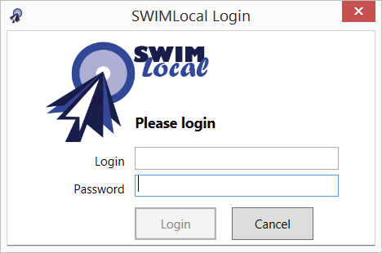The login screen provides login (username) and password fields. The user must successfully log in to access any part of the application. Shutting down the application logs the user out of the software. Once logged in the user remains logged in until the application is shut down. A user must be an administrator in order to log in to this application.

## Home screen

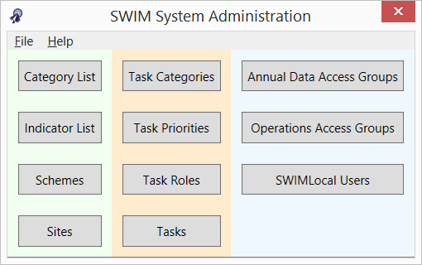The home screen is the first screen seen when logged in as an administrator. The home screen provides buttons to access all data management functionality. Functions are organised into logical groups (schemes, indicators, sites, etc.) within three sections (Indicators module (pale green), Task module (pale brown) and Users (pale blue).

## Manage SWIM*Local* users

SWIM*Local* uses different user roles and access groups to help limit which components of the software people can access and use. There are two ways in which this is done; firstly, via user ‘roles’ which limits which software tool a user can login to; and secondly, via ‘access groups’ which limits which schemes and categories a user can see within those software tools. Every user must have at least one role and one access group associated with them to access the software.

### Adding/editing a user

Click on the ‘SWIM*Local* Users’ button.



The SWIM*Local* users screen lists all users for the organisation (list of user logins, first name and surname, role and active status). It is sortable by clicking on column header. It provides functions to add or edit a user. Inactive users are not shown in the list unless the ‘Show inactive’ tick box is selected (bottom middle).

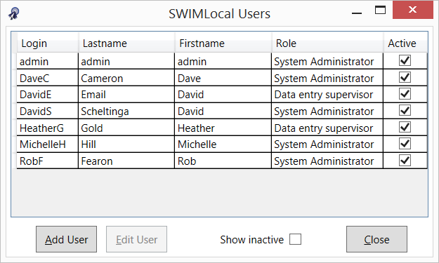

To add a new user click the ‘Add User’ button. This opens the screen shown below.

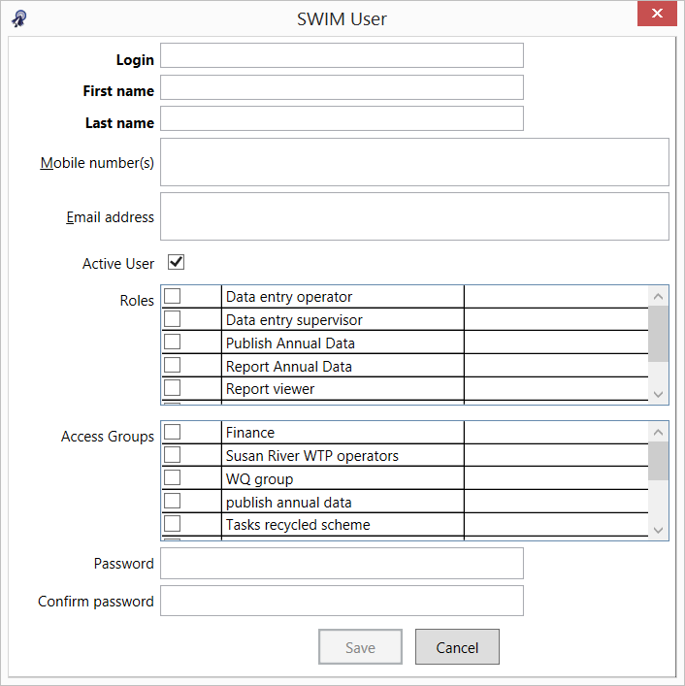

Complete all the SWIM user fields.

We recommend using a familiar login system consistent with your organisation or at the least within SWIM*Local*.

A mobile number and email address is optional but either/both are needed if the user is to receive any alerts as they are used for alerting functionality of indicators and tasks. Mobile number must be entered without spaces, e.g. 0415123456. Multiple mobile numbers and email addresses can be entered and must be separated by a comma, e.g. 0415123456, 0414654321. **Note** that mobile numbers can be in international format (e.g. +61) if you wish or national (e.g. no +61).

A user can be made inactive by un-selecting the ‘Active User’ tick box. For referential integrity reasons users cannot be deleted once created and they can only be made inactive. An inactive user cannot login to SWIM*Local* software.

User roles and access groups can be selected by clicking (ticking) the appropriate boxes.

Once a password has been entered and confirmed correctly the ‘Save’ button will become active and can be selected to save the new/edited user profile.

To edit a user select the user you wish to change and then click ‘Edit User.’ You can then change any of their details such as roles/access level and password. To prevent unfortunate mistakes the currently logged-in user cannot change their own access level.

#### User roles

Seven SWIM*Local* user role types have been set up within the software as described in the following table. The software has been implemented as four separate tools (applications) which can be installed independently (for example, a ‘Report viewer’ users in council administration will only require the Reporting tool software to be install as this is the only tool that they can access).

Users can be assigned multiple roles (by selecting multiple roles) to allow access to the different SWIM*Local* tools they need. So for example, if you have an Annual Data Reporting User who also needs access to operational data via the Reports tool then you can give that user both ‘Report annual data’ and ‘Report viewer’ roles and then limit what they can see via the Reports tool by using the Operations Access Group functionality (see below).

Table 1. User roles.

|  |  |  |  |
| --- | --- | --- | --- |
| **User role** | **Using SWIM*Local* for** | **SWIM*Local* software tools that user role can access** | **Controlled by ‘access groups’** |
| Data entry operator | * Site operational data entry and reporting * Site task completion and reporting | * Operations – Data and Tasks * Reports * Mobile app (data entry) | Yes |
| Data entry supervisor | * Site operational data entry and reporting * Site task completion and reporting * Change schemes visible in the Operations tool[1] | * Operations – Data and Tasks * Reports * Mobile app (data entry) | Yes |
| Publish annual data | * Annual data entry (SWIM) * Releasing annual data for publication | * Annual data | Yes |
| Report annual data | * Annual data entry (SWIM) | * Annual data | Yes |
| Report viewer | * Reporting of data and/or tasks | * Reports | Yes |
| System administrator | * Administer SWIM*Local* metadata and user accounts (but may also do operations and annual data entry (including ‘publish’), task completion and all reporting) | * Admin * Operations – Data and Tasks * Annual data * Reports * Mobile app (data entry) | No (with the exception of the mobile app) – complete access to all functionality and tools[2] |
| Task user | * Site task completion | * Operations – Tasks only | Yes – at the scheme level[3] |

#### Access groups

Access groups allow the SWIM*Local* administrator control over exactly what schemes/site/indicator categories a user can access. Access groups are divided into ‘Annual Data’ (controlling Annual data tool scheme/indicator access) and ‘Operations’ (controlling Operations tool scheme/site/indicator access) categories.

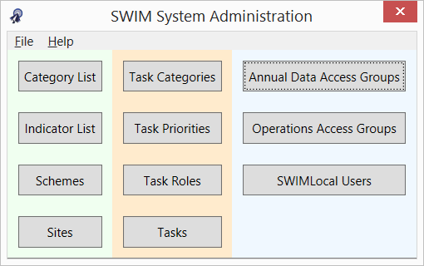

##### Annual data access groups

The annual data access group allows you to control which SWIM indicator categories and schemes (i.e. annual water and sewerage data) that can be accessed by a user. Click on the ‘Annual Data Access Groups’ button and the below window will appear. From this window you can add, edit or show inactive access groups.

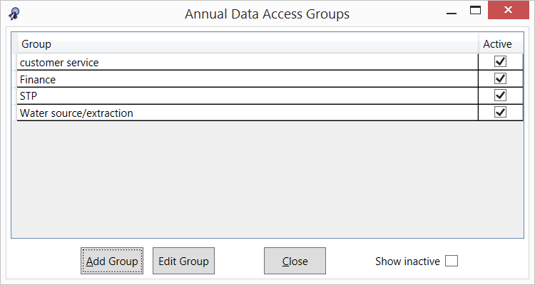

Clicking the ‘Add Group’ button brings up the following window.

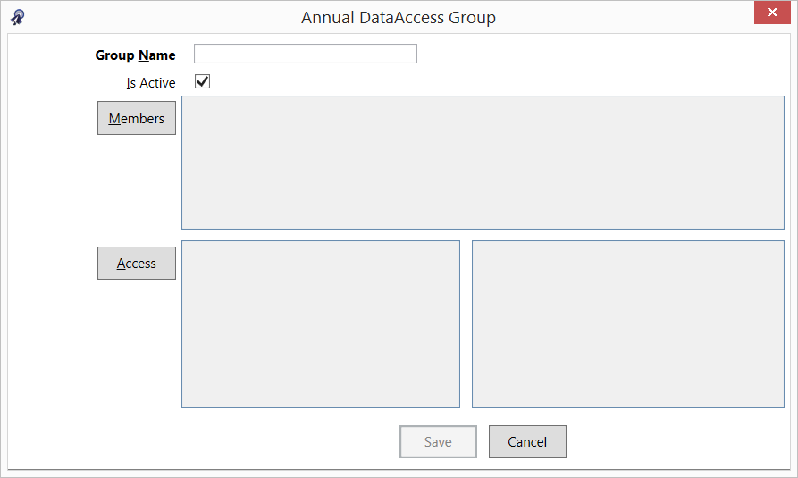

Enter an appropriate name for your access group.

Groups can be made active or inactive by selecting the ‘Is Active’ tick box.

Click the ‘Members’ button to select which users will be within the group.

Click the ‘Access’ button to select which schemes and SWIM indicator categories the group can see (see following window).

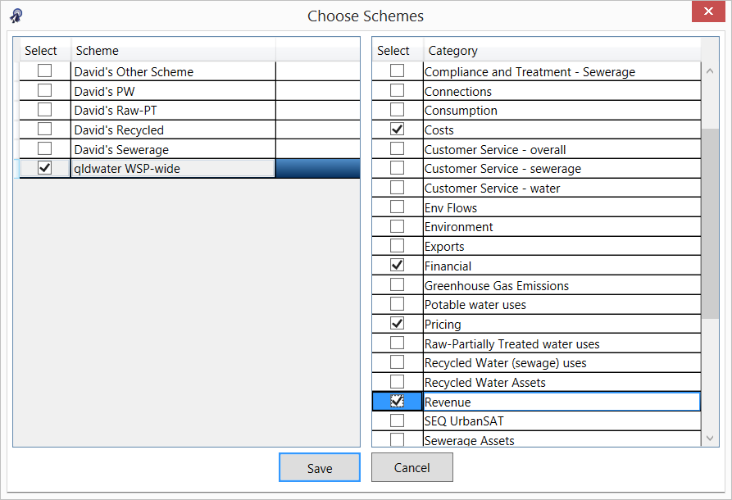

Once the appropriate details have been selected/entered then the save button becomes active and can be selected.

##### Operations access groups

The operations access group allows you to control which of your organisation’s indicator categories and schemes/sites (i.e. those in your Operations tool and mobile data entry application) that can be accessed by a user. Click on the ‘Operations Access Groups’ button and the below window will appear. From this window you can add, edit or show inactive access groups.

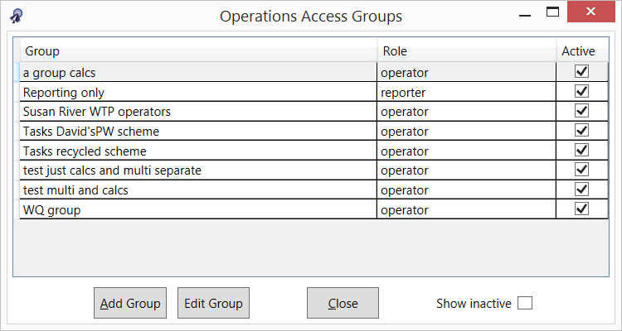

Clicking the ‘Add Group’ button brings up the following window.

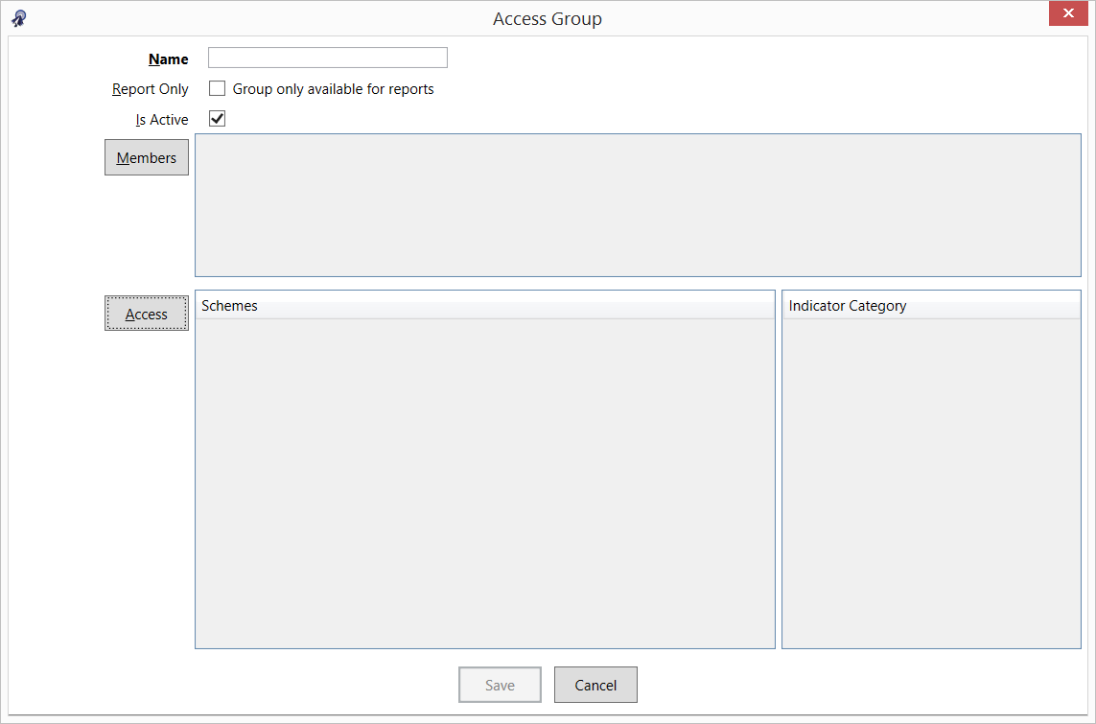

Enter an appropriate name for your access group.

Operations access groups can be made ‘Report Only’ by selecting the tick box. This means that the group can view all the appropriate data via the reporting tool and cannot change the data. **Note** that any user, even one with a ‘Report Viewer’ role, must be in an access group that has the report only box ticked (see below) for them to be able to login to the Reports tool (and access the appropriate data). **Note** that Users in a ‘Report Only’ access group cannot access/manage data even if they have been assigned a data management role (e.g. an Operator). The ‘Report Only’ access group is purely for Users who you only want to be able to look at and extract data but not be able to alter it.

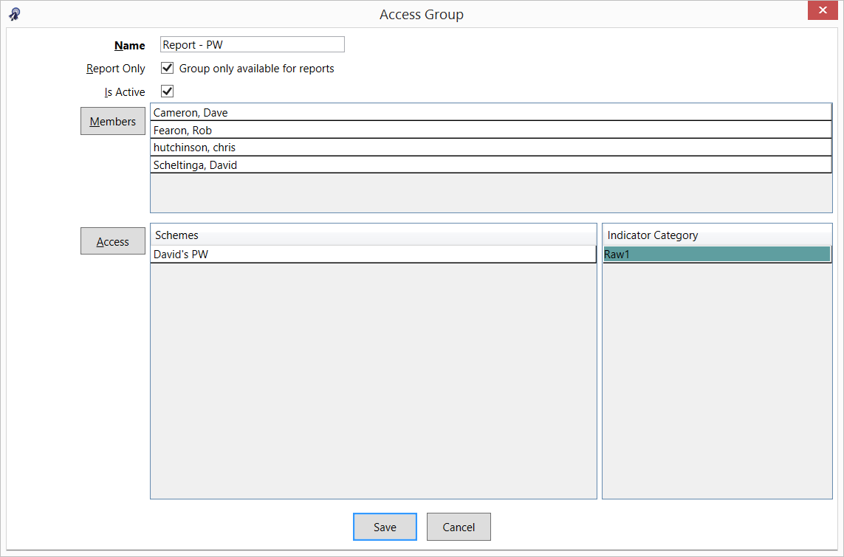

Groups can be made active or inactive by selecting the ‘Is Active’ tick box.

Click the ‘Members’ button to select which users will be within the group.

Click the ‘Access’ button to select which schemes and indicator categories the group can see (see following window).

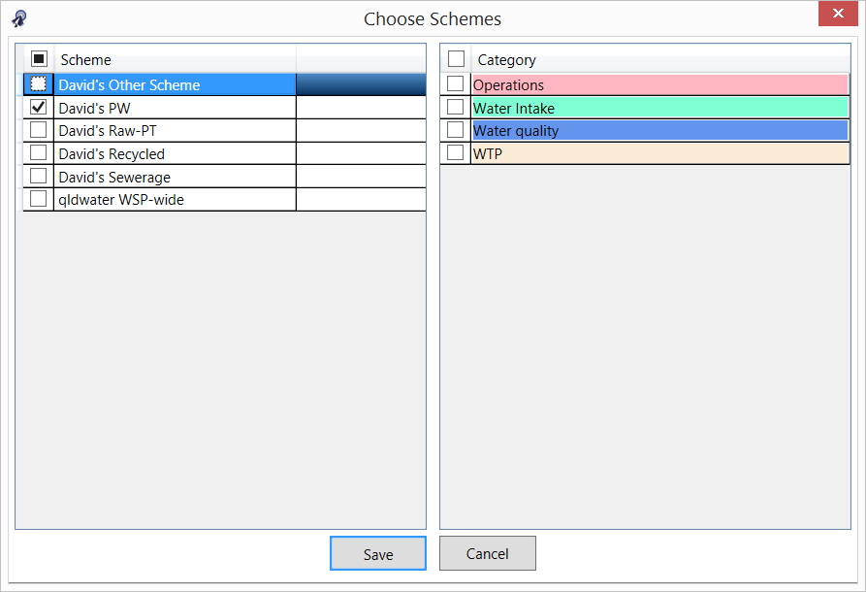

Once the appropriate details have been selected/entered than the save button becomes active and can be selected.

**Note** that when setting up an access group for a ‘Task User Role’ then you only need to select the appropriate schemes (left side of window) and not categories (right side of window).

### Common alert/error messages during user login

If a user tries to access one of the SWIM*Local* software tools that they do not have permission to open then they will see the following window pop up. For example, if a user with an operator role tries to open the Admin tool software.

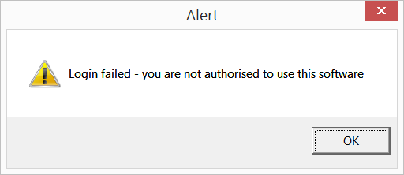

If a user tries to access one of the SWIM*Local* software tools that they do have permission to open but they have not been assigned the appropriate access group then they will see the following window pop up. For example, if a user with an operator role tries to open the Operations tool software but hasn’t been assigned to an operations access group.

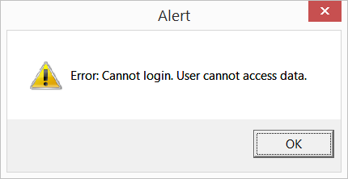

Similar messages will appear for the same reasons when trying to login to the mobile data entry application.

# SWIM*Local* Annual Data Tool

The SWIM*Local* Annual Data Tool is free to use for all ***qldwater*** members. It is used to report your regulatory required annual water and sewerage data (i.e. SWIM data) to the requesting organisation. **Note** that by default the Annual Data Tool only displays indicators that are requested of your organisation under some piece of legislation (i.e. mandatory indicators). It can also include ‘voluntary’ indicators, such as some additional ones for the ***qldwater*** *Annual Water and Sewerage Benchmarking Report* if specifically requested by you.

## Login screen

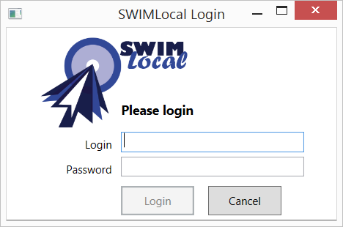

The login screen provides username and password fields. The User must successfully log in to access any part of the software. Shutting down the tool logs the User out of the software. Once logged in the user remains logged in until the software is shut down. A User must have a role of ‘System administrator’, ‘Report annual data’ or ‘Publish annual data’ and be in an appropriate ‘access group’ in order to log in to this tool. **Note** that both the login and password are case sensitive.

Access to the Annual Data Tool is controlled by your organisation’s SWIM*Local* ‘System Administrator’ via the SWIM*Local* Admin Tool. Access can be limited to any combination of SWIM categories and/or schemes, e.g. from just a single category (such as the ‘Revenue’) of indicators or all categories, or it can be limited to any combinations of schemes, e.g. just a single scheme, or combinations of both schemes and categories, e.g. all sewerage schemes and the revenue, cost and finance categories of indicators.

## Home screen (data entry)

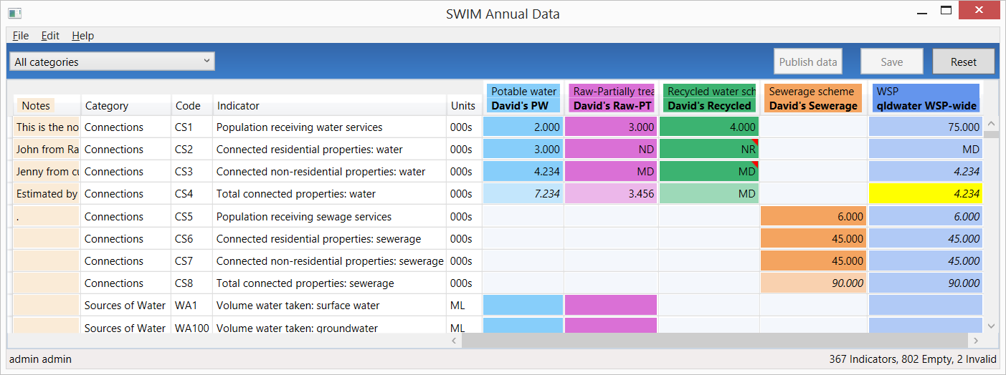

The data entry home screen is the primary data entry screen in the tool. It presents a grid control (spreadsheet format) with options to choose between different data entry locations (schemes and organisation) and indicator categories for the SWIM indicators. Users input values by typing into the grid cell for the appropriate indicator. Only coloured cells require data (i.e. grey cells do not require data to be entered). When data is first entered it will appear in **bold**, once the data has been saved it loses the bold appearance.

If data has been entered and saved the cell cannot be made blank/empty again. If the value was wrong then it must be replaced with either the correct value or MD (Missing Data). **Note** that any data can be corrected at any time. However, once the data has been sent to the requesting agency then any changes in SWIM*Local* will be saved there but they will not be automatically resent to the requesting agency.

All column widths can be adjusted and will save on close. The screen can scroll left and right if needed but will not scroll past the indicator title column.

Columns (left to right) and their function:

* *Notes* (beige background) – allows the user to enter any notes/comments/related text that is useful for now and future users (e.g. Data from Jenny Smith from Finance, Data estimated using the following method “X divided by C”). This information is not sent to anyone and will be included/visible in next year’s ‘sheet’.
* *Category* – lists the SWIM category that the indicators sit within. You can filter by category.
* *Code* – lists the SWIM code of the indicator. You can filter by the agency requesting the indicator.
* *Indicator* – lists the short indicator title.
* *Units* – lists the units that the indicator must be reported in.
* *Potable water scheme*[4] (light blue background[5]) – shows (as columns) all the potable water schemes that were active during the reporting period that require data to be entered. Potable water is intended for use as drinking water and should materially meet the Australian Drinking Water Guidelines 2004, or equivalent.
* *Raw-Partially treated water scheme*(purple background) – shows (as columns) all the raw-partially treated water schemes that were active during the reporting period that require data to be entered. Raw-Partially treated water is non-potable water. It is sourced from surface or groundwater.
* *Recycled water scheme*(green background) – shows (as columns) all the recycled water schemes that were active during the reporting period that require data to be entered. Recycled water can be either potable or non-potable water. It is sourced from either sewage, stormwater or drainage water.
* *Sewerage scheme*(orange background) – shows (as columns) all the sewerage schemes that were active during the reporting period that require data to be entered.
* *WSP* (dark blue background) – is where data for the ‘Whole of Service Provider’ scheme is entered. Is most cases the WSP value is a calculation (sum) of other indicators/schemes.
* *NPR footnotes* – this column is only visible to Users who must report to the NPR (National Performance Report). Any text entered here is associated with the whole indicator and not specific data points. The information is sent to the NPR for information and possible publication.

## File tab (export, print, sync)

Under the file tab the User can:

* Export the data as an Excel file (both with and without comments). To export with comments select ‘Excel file (with data comments) (*.xlsx)’ from the ‘Save as type:’ selector panel (see below)
* Print the data
* Synchronise the data (also done by pressing the F5 key)
* Exit the software

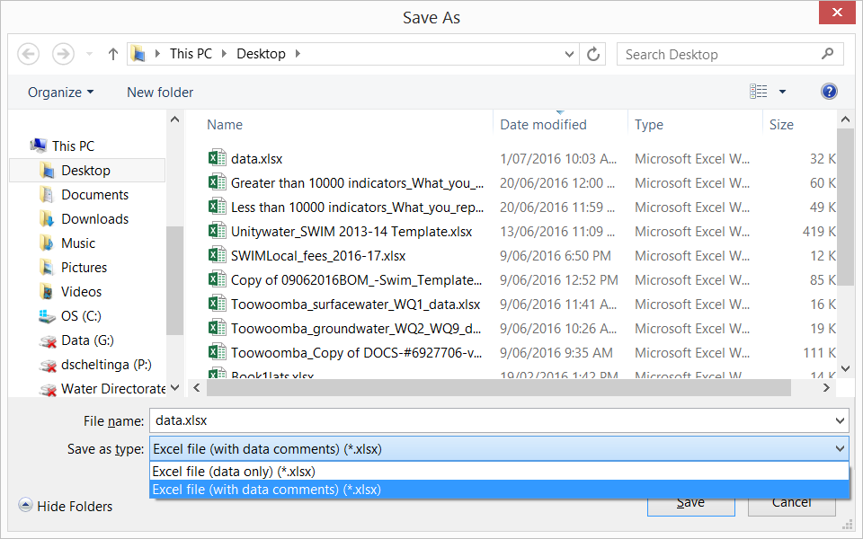

## Edit tab (find function)

Under the Edit tab the User can:

* Find an error (red background) cell, an invalid (yellow background) cell, an empty cell, an indicator (via its SWIM Indicator code) or a value (number or text). The find function can also be accessed by pressing the ‘Ctrl’ + ‘F’ keys together
* Find next (also done by pressing the F3 key). Once you have found one invalid cell you can just press ‘F3’ to find the next and continue throughout

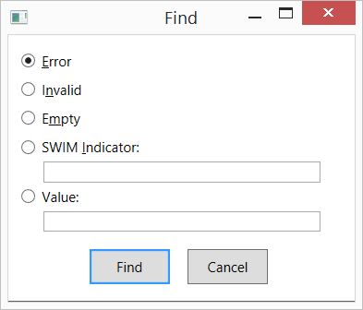

When searching for a cell value the find function matches the displayed and edit value for numbers (i.e. searching for 15.6 will find a value which displays (with one decimal) as 15.6 but actually contains the number 15.557). Text cells match anywhere in the value (e.g. will search inside notes, so searching for ‘is’ will find a note containing “This note number is 150”). Numbers and indicators match from the start of the number (15 will match 15, 150, but will not match 215, WA15 will match WA15, WA150 but will not match WA115). Regular expression wildcards can be used in the search text if needed.

Search for text (Value) is case sensitive and only searches the ‘Notes’ and ‘values’ cells. It doesn’t search the comments.

Once the find function has searched the entire grid it offers to start again at the top, so pressing ‘F3’ (find next) repeatedly will let you loop through the entire sheet.

## Help tab

Selecting the ‘Help’ and then ‘About’ tabs will bring up a window with information about your SWIM*Local* system.

This information is often needed by ***qldwater*** if there are any issues with the software. You may be asked to copy and send.

The useful information for you is the:

* The server being used (row 3): this shows which server the system is connected to. You can connect to a ‘training’ server for testing purposes. In this case “http://swim.qldwater.com.au” is the production (real) server.
* Last sync time (row 4): this shows what time the system last successfully synchronised with the SWIM server.
* Current reporting year (row 6): this shows which reporting year you are entering data for – for the 2015/16 reporting year the system will display 2016.
* Log (row 7): this shows where the SWIM*Local* log files are saved on your computer. These may be needed in the event of errors occurring.

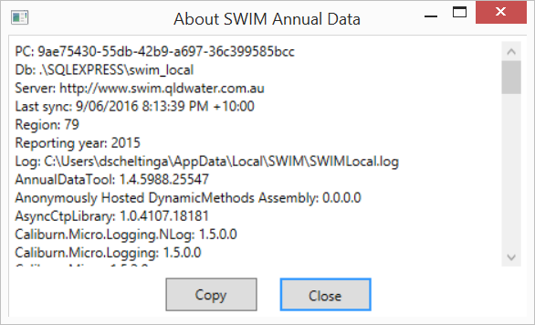

## Filtering indicators

You can filter which indicators are visible by either indicator category or by the name of the agency the indicators are requested by.

Indicator categories used in the filter are the SWIM categories used to link similar groups of indicators. To do this click on the drop down box at top right and select the indicator category you wish to look at (see below). You can only select one category at a time.

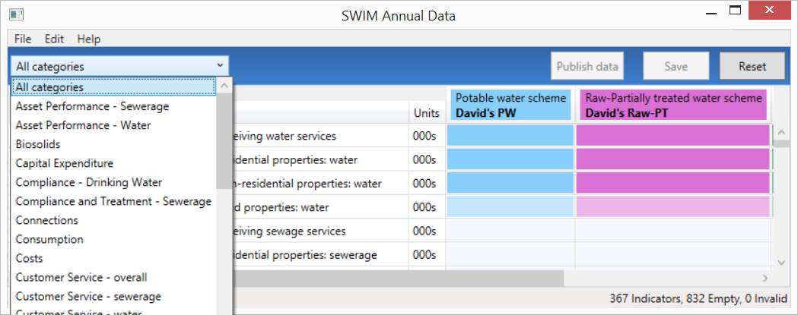

You can also filter by the agency requesting the indicators via the second drop-down box at the top right. To do this click on the drop down box and select the ‘agency’ you wish to look at (see below). You can only select one agency at a time. **Note** that in most cases all agencies will appear in the list even if you are not required to report to them. This is because SWIM takes out indicator duplication for you and only shows one indicator even if it is requested by multiple agencies. **Note** that data will only ever be sent to the agency that your organisation is required to send data to. So for example, WA1 (Volume water taken: surface water) is requested by NPR, ABS and DEWS. If your organisation has less than 10,000 water connections then the data will only be sent to ABS and DEWS, but if your organisation has greater than 10,000 water connections then the data will be sent to all three – as required by legislation.

The agencies are:

* ABS – Australian Bureau of Statistics (Annual Water and Sewerage Survey). Required for: all Qld Service Providers
* BoM U-code – Bureau of Meteorology (Category 7 (U-code) indicators). Required for: Category L persons named in the Water Regulations
* DEWS KPI – Department of Energy and Water Supply (Key Performance Indicators). Required for: all Qld Service Providers
* NPR – Department of Energy and Water Supply (Key Performance Indicators) and Bureau of Meteorology (Category 7 (W-code) indicators). Required for: all Qld Service Providers with greater than 10,000 water connections
* QCA – Queensland Competition Authority (SEQ Retail Water Annual Performance Monitoring). Required for: five SEQ entities (**Note** that for 2015/16 reporting this has been built into the SWIM system but is currently inactive and data is not sent)

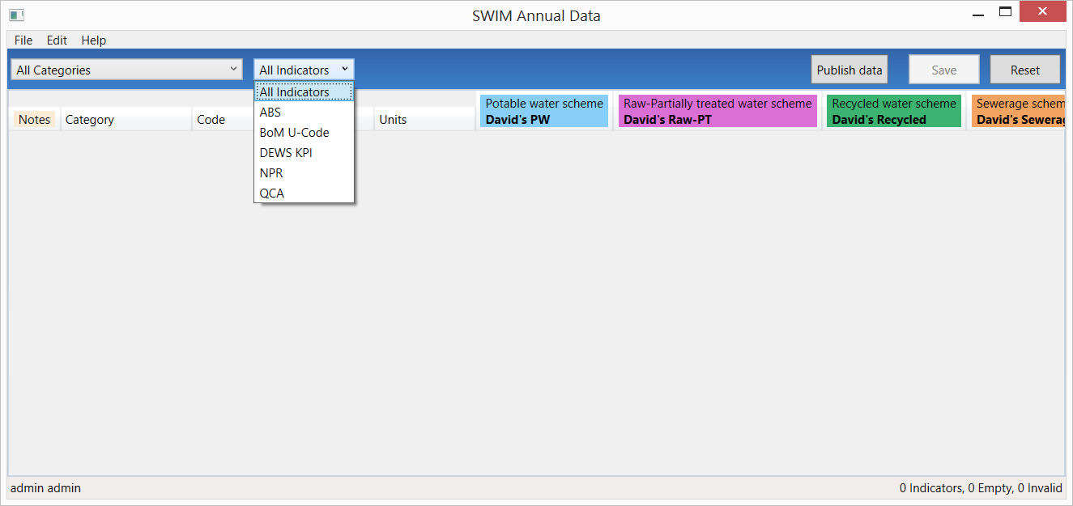

## Save button

The save button saves the data to the computer/device being used. The font of the values entered will change from **bold** to normal after the data has been saved. Note that saving the data is different to synchronising the data. You must synchronise the data for it to be sent to the SWIM/central synchronising server and to be available to other users.

If you try and save the data and get an error message saying it cannot save (see below) then this means that you have ‘red’ invalid data that is impossible to have (i.e. text in a numeric only cell) and it must be corrected before it can be saved. Use the ‘find’ functionality to search for the invalid cell and correct before saving.

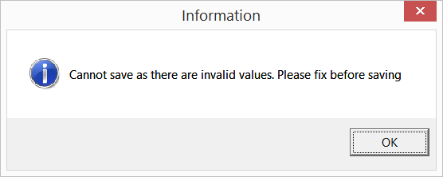

If you try and exit the software without first saving the data you will get a message (see below) warning you to save the data first. **Note** that unsaved (bold) data will not be saved if you exit without first saving it.

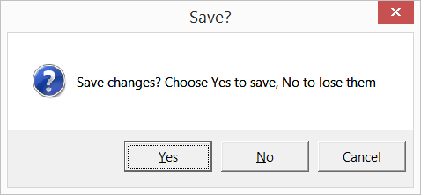

## Reset button

The reset button allows the user to reset the data back to the last save point (see below). It is used if something has gone wrong (i.e. entered incorrect data and can’t find to fix) and you need to clear what has been entered. **Note** that it only clears back to the last save point.

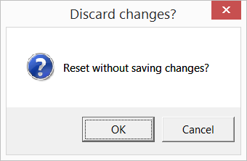

## Mouse (cursor) hover-over functionality

The mouse (cursor) hover-over function allows the user to see further information about a particular aspect of the indicators, as follows:

* SWIM Code – allows the User to see the other codes used for this indicator by all the requesting agencies (see below)
* Short Indicator title – allows the User to see the full indicator description and other helpful information
* Scheme short title – allows the User to see the long scheme name
* Data cells - allows the User to see the further information about the value, such as, validation rule used, comments, previous year’s values, reason for being ‘yellow’ invalid (e.g. missing calculated value), calculation used

## Missing data (MD)

The user can enter ‘MD’ into any cell to identify that an indicator has Missing Data.

**Note** that a zero (0) must not be used for missing data. Missing data (MD) is used when you do perform an activity but for some reason (e.g. broken meter) do not have any data for that indicator.

## Not relevant (NR) indictors

The user can enter ‘NR’ into any cell to identify that an indicator is Not Relevant. **Note** an indicator is only ‘Not Relevant’ if the organisation does not do the activity now and never has. For example, volume groundwater extracted, if you have no bores and do not extract any groundwater for use in water supply then you could report this indicator as ‘NR’. Note that it is possible to have some schemes as ‘NR’ and others with values for the same indicator, e.g. Potable Scheme A uses bore water (value entered for groundwater extracted) but Potable Scheme B only uses surface water (NR for groundwater extracted).

The software can handle ‘NR’ in source/raw data indicators used to generate calculated cells (it considers it a ‘0’ for calculation purposes).

## Calculated indicators

Cells for calculated (i.e. derived) indicators are populated with values as soon as the necessary related values are entered. The calculated indicator value can be replaced by a typed-in value – if replaced then changing the source data values of the calculated indicator will not change the typed-in value. Calculated indicator cells are recognised by being a ‘half shade’ lighter than the raw (user entered) data cells and with the calculated value appearing in *italics*. **Note** that if a calculated value is over-written then the value will no longer appear in italics. See screen grab below – indicator WA3/David’s PW scheme is calculated (light blue background and in italics), while WA109/David’s PW is calculated but has been over-written (light blue background and not italics).

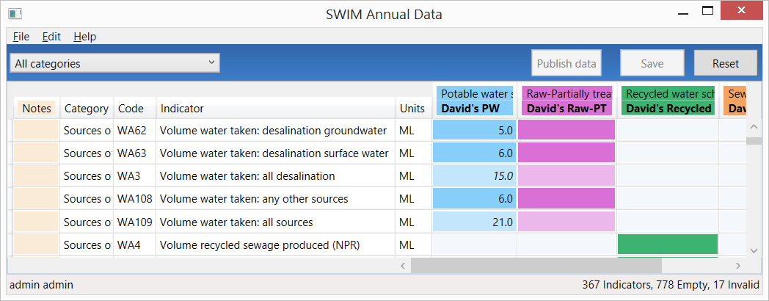

If you have over-written a calculated value you can revert back to a calculated value (i.e. derived from other indicators) by right clicking the appropriate cell and selecting ‘Revert to calculated value’. The font will then return to *italics*.

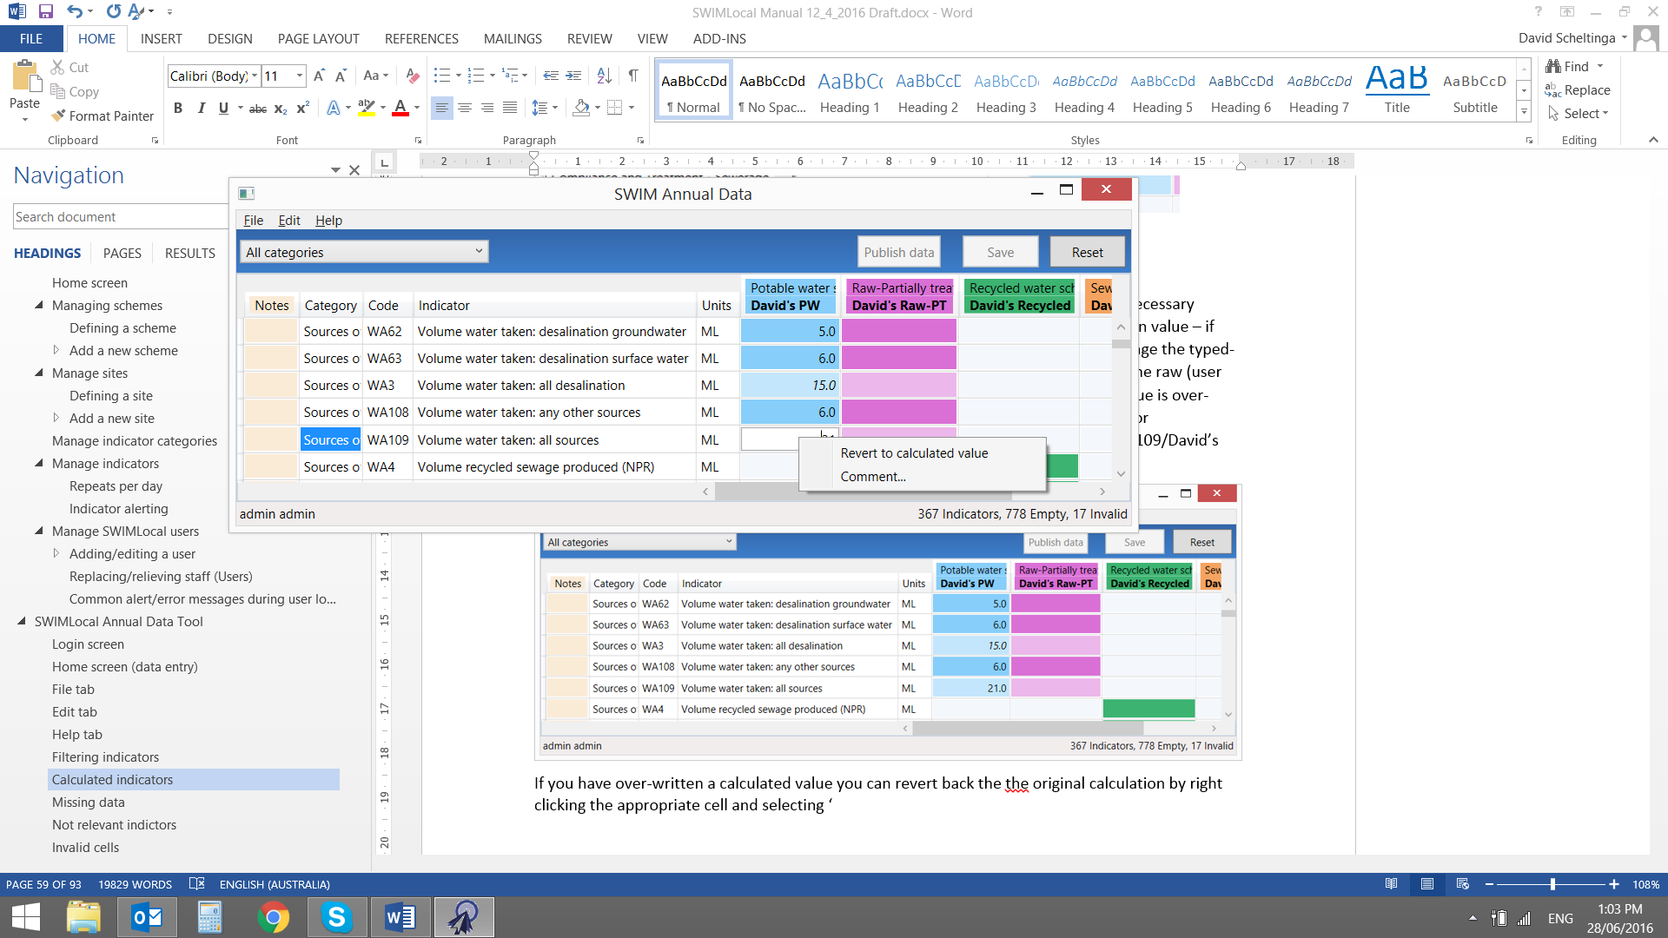

The software can handle ‘NR’ values for indicators from which calculated fields are derived (it considers it a ‘0’ for calculation purposes).

If there is ‘MD’ (missing data) entered for the raw data used in a calculation then the calculated cell will still calculate but it will be highlighted yellow as there is missing data (mouse hover-over function will display this (see below)). You will then have two options:

1. if the calculated value is appropriate (i.e. the missing value is insignificant) then you would ‘accept as true’, or
2. if the calculated value is not appropriate (i.e. the missing value is significant) then you would either:
   1. replace the calculated value with the real value if know or estimated, or
   2. replace the calculated value with ‘MD’ (missing data).

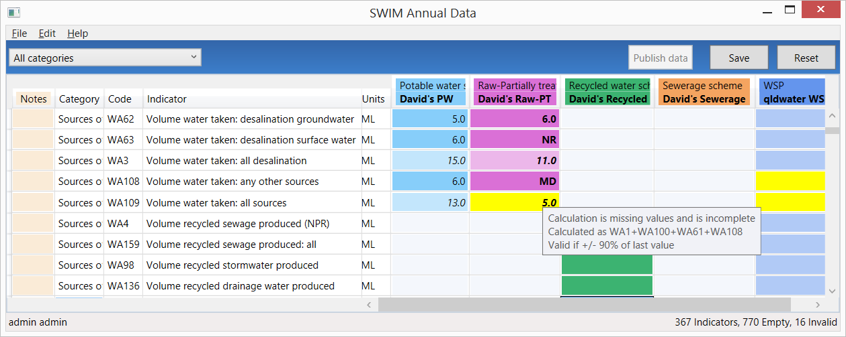

You are able to see where (if) a value is used in a calculation by holding down the Ctrl key and right clicking on the cell. The values that the cell is used for are then highlighted red (see below). So in this example, CS2 is used to calculate CS4 potable scheme (CS4=CS2+CS3) and CS4 WSP scheme (CS4=sum of all potable and raw-PT scheme values).

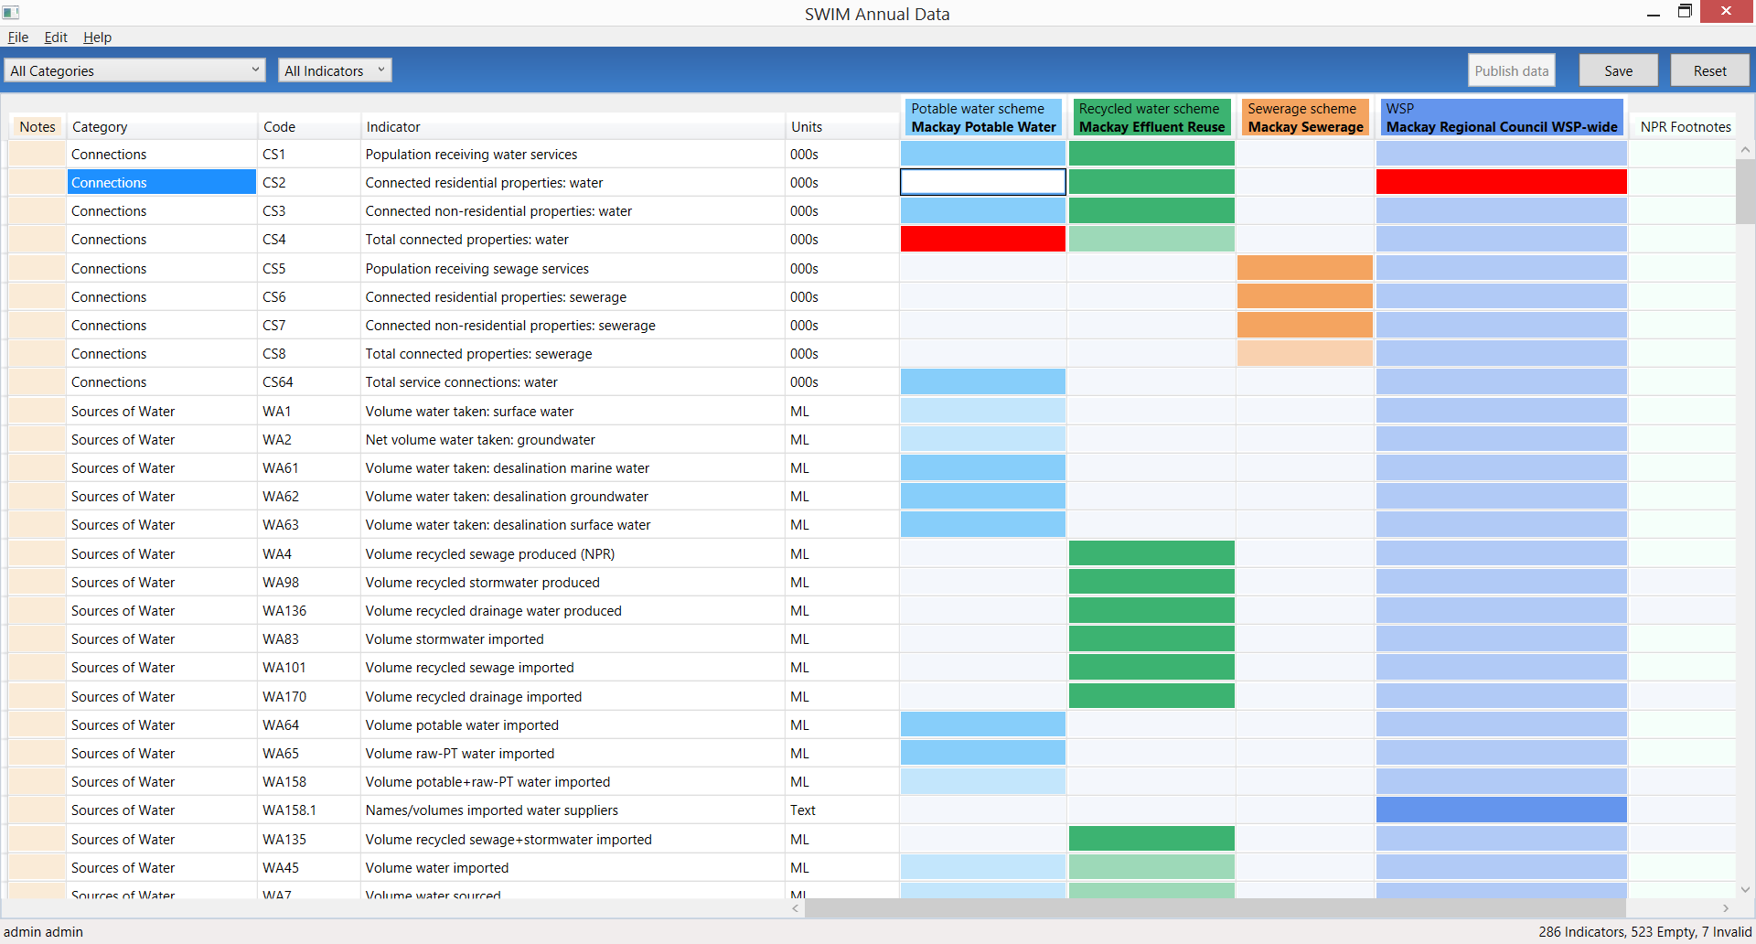

## Invalid/error values

There are two types of invalid cells (either yellow or red background highlighted). Yellow invalid cells are generally ones ‘in progress’ or could be true but need checking and can therefore be saved but not published. Red error cells are ones that cannot be true, i.e. they are errors, e.g. text in numeric cells, and cannot be saved (must be fixed before saving/exiting the software).

### Yellow highlighted ‘invalid’ cells

There are 2 reasons for a yellow invalid cell:

1. Calculation is missing data or incomplete (a calculated indicator will start doing the calculation as soon as one of the raw data values is entered, and will stay yellow until all raw data values are entered), or
2. The value entered is outside the validation range set up for that indicator. For example, the validation range can be; last year’s value +/- 10%, range 1-14.

The mouse hover-over function will help determine the reason for the invalid ‘yellow’ cell. If it says that the ‘Calculation is missing values and is incomplete’ then that is the reason for the yellow invalid cell. If it does not say this then the reason is that it is breaking its validation rule (which is shown in the mouse hover-over, e.g. +/- 10% of last year’s value). The software will still allow the user to save the data with yellow invalid cells present.

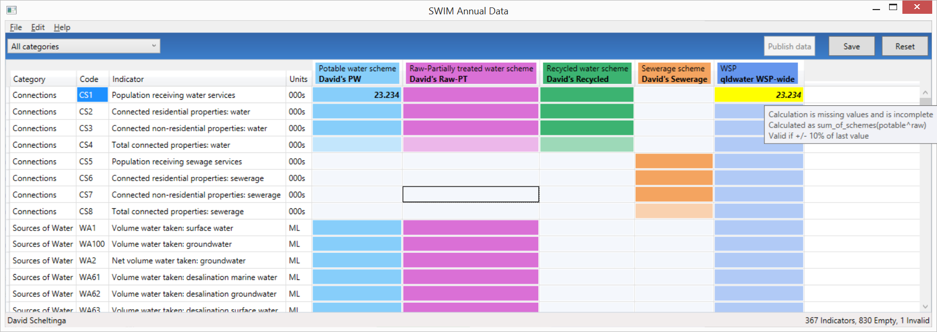

If the yellow invalid cell is correct then the user needs to accept the value as true. To do this the user right clicks the cell and selects the ‘Accept as true value’ option. Once this has been done the cell background colour will return to normal.

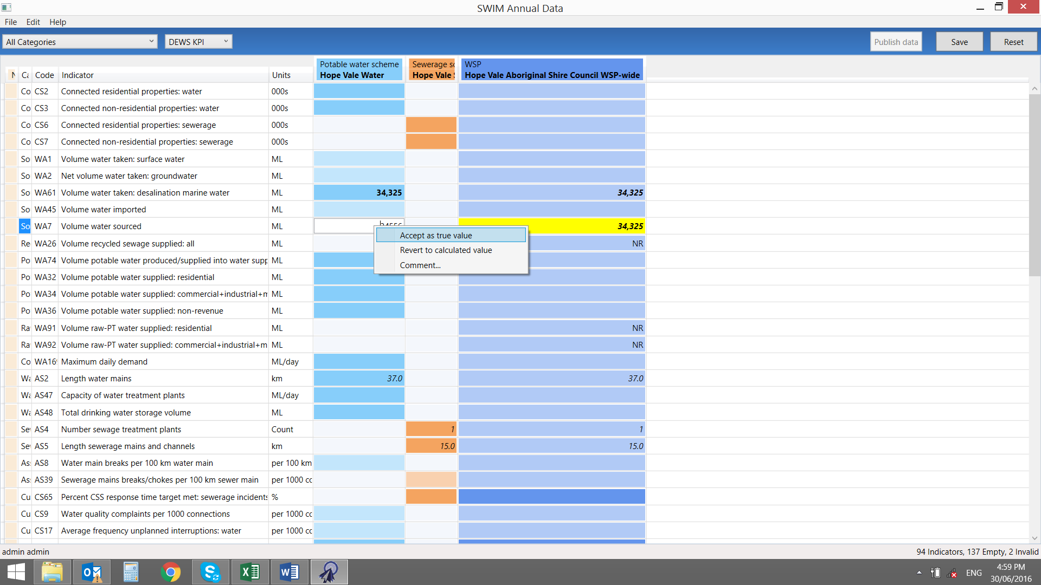

### Red highlighted ‘error’ cells

There are 3 reasons for a red error cell:

1. The system has done a calculation which has tried to use a ‘MD’ (Missing Data), ‘NR’ (Not Relevant) or ‘0’ in a complex multiplied/divided by calculation. The cell will either contain the text ‘Div/0’ or ‘ERROR’ as shown below. These error cells are not always immediately obvious as they may be anywhere in the system/screen. They can be found via the Find functionality under the ‘Edit’ tab.

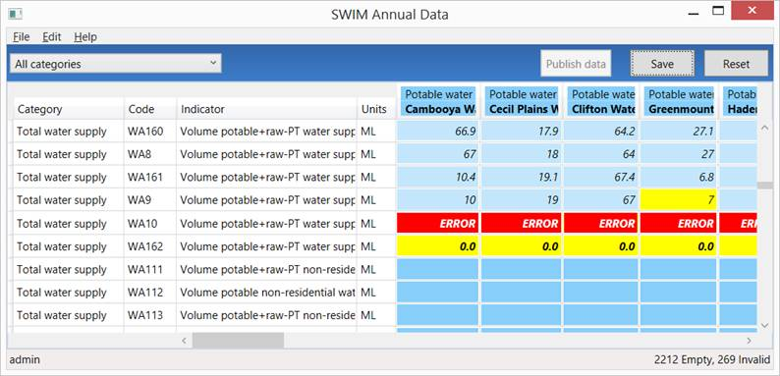

1. The software will not permit any input of non-number values, or values which are not a valid number (for example, containing repeated minus (--), plus (++), decimal (..) symbols). It does allow the use of negative (-), less than (<) and greater than (>) signs. These error cells are easily seen (and found) as they occur in the cell you have just entered data in and you will see them highlighted in red straight away.
2. The information entered into a data cell is not in the correct format. For example, text entered into a number only cell or incorrect format/words in a text cell, e.g. ‘YES’ instead of ‘yes’. The system has been made to be very specific as too what can be entered into some text cells (as requested by agencies requesting the data). The Units column will display the appropriate format. It will say ‘text’, ‘yes/no’, ‘ok/not ok’, etc. (see below). It is case sensitive. If the Units are ‘text’ it means that any text/words can be entered. These error cells are easily seen (and found) as they occur in the cell you have just entered data in and will be highlighted in red straight away.

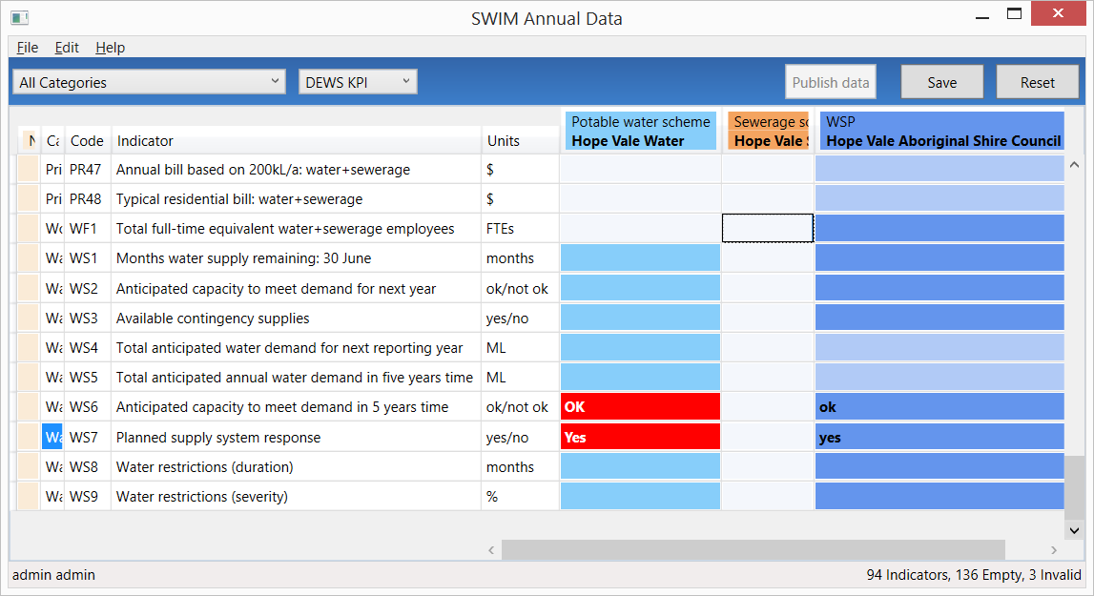

Once you find the red error cells you will need to decide on what has caused it and what to do. Use the mouse hover-over functionality to see if it is a calculated cell and how the calculation is done. In general these calculation errors can be replaced with either MD, NR or 0.

**Note** that the system will not let you save the data if it contains any red error cells. The following message will be displayed when the ‘Save’ button is selected.



## Adding a comment to a data point

If you want to add a comment, accept an invalid cell as ‘true’ or revert back to the original calculation (if you have overwritten a calculated value) then you do this by:

1. Selecting the specific cell you want to change.
2. Right clicking on the cell and a ‘text’ box will appear (see below).
3. Clicking on the appropriate option.

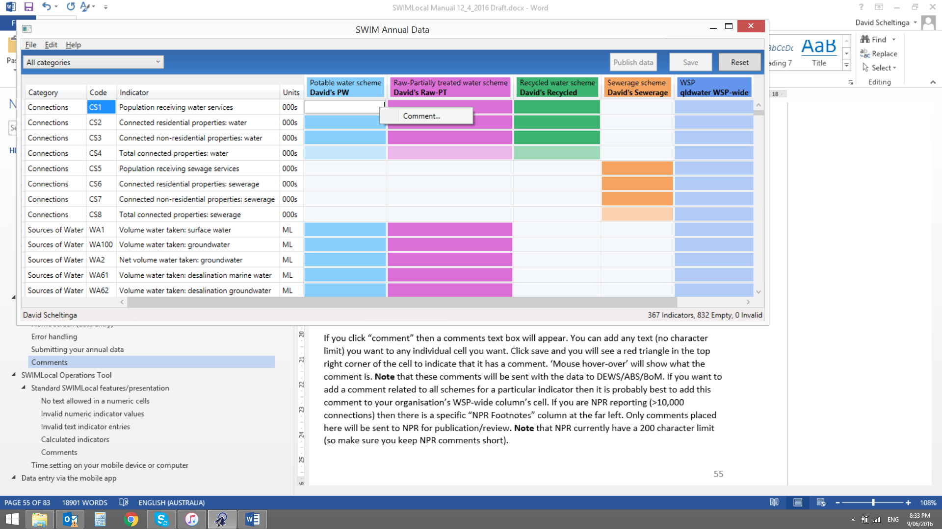

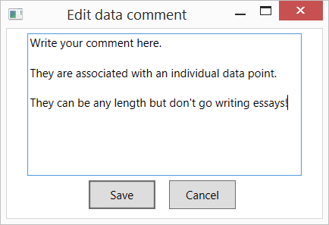

If you click ‘comment’ then a comments text box will appear. You can add any text (no character limit) you want to any individual cell you choose. Click save and you will see a red triangle in the top right corner of the cell to indicate that it has a comment. Mouse hover-over will show what the comment is. **Note** that these comments will be sent with the data to DEWS/ABS/BoM. If you want to add a comment related to all schemes for a particular indicator then it is probably best to add this comment to your organisation’s WSP-wide column’s cell. If you are NPR reporting (>10,000 connections) then there is a specific ‘NPR Footnotes’ column at the far right. Only comments placed here will be sent to NPR for publication/review. **Note** that the NPR no longer have a character limit on NPR footnotes but you should still try and keep them short but still sufficient to describe the situation.

The mouse hover-over function allows you to view/read any comments.

Comments can be edited or deleted at any time using this process.

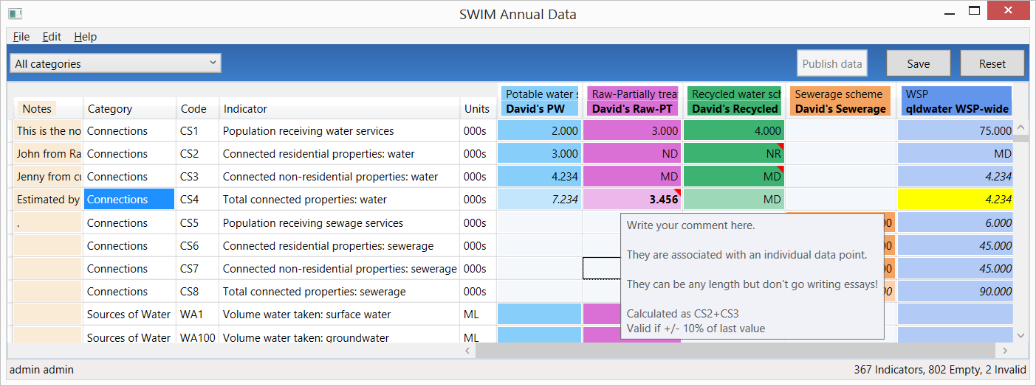

## Publishing data

Only a User with a role of either ‘System Administrator’ or ‘Publish Annual Data’ is able to publish the data (that is, approve the data for release to the agencies requesting the information). These Users are the only Users who will actually see the ‘Publish data’ button.

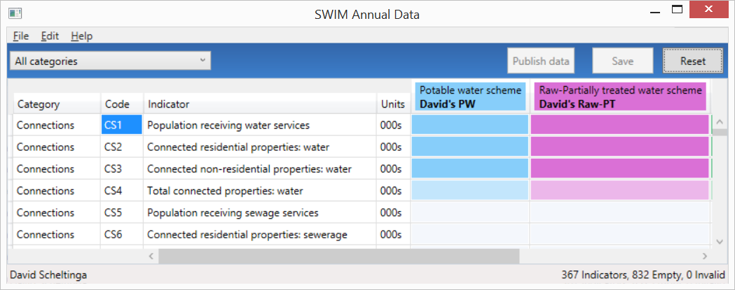

To ‘Publish’ your data you MUST have zero (0) Empty and zero (0) Invalid cells (either red or yellow). (This is shown in the bottom right corner of the Annual Data Tool window - see screen grab below).

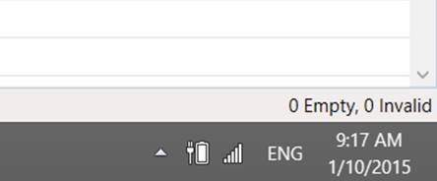

If you still have any Empty or Invalid cells the software will not let you ‘publish’ the data. To find any of these you can use the find function under the ‘Edit’ tab. You can then use the ‘F3’ button to continue to find the next invalid cell throughout the sheet.

Once you have 0 Empty, 0 Invalid cells then first Save the data. The ‘Publish Data’ button at the top right will then become active. When you are happy with all your data, click the ‘Publish Data’ button and it will ask for confirmation, then it will say that the data is published and the button will now say ‘Data is Published’ and be bright yellow.

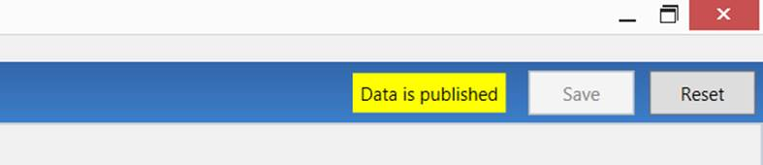

You MUST still synchronise the data before the ‘Publish data’ is complete (the synchronise sends everything through to the SWIM database so it also knows that the data is published and ready to be sent). You can manually synchronise via the ‘File – Sync Data’ tab at the top right or just push the ‘F5’ key. The software automatically synchronises on closing/exit.

If you have ‘Published’ your data you can still check and correct/change the data at any time throughout the year BUT make certain that you check any changes do not result in ‘invalid’ yellow cells (these will need to be checked and then accepted as true).

When you change any data the system automatically sets the data to ‘unpublished’ and the ‘Publish data’ button will change back to its original plain colour. You will therefore need to click the publish data button again to publish it – otherwise organisations such as DEWS, BoM and ABS will not be able to access your updated data.

Once your data is “Published” it will be sent (as appropriate) to DEWS (KPIs and NPR (for those with >10,000 connections)), ABS and BoM in the appropriate format for each organisation. This will occur after 5 pm on the due date that the data is due to each of the agencies. This means that you will need to publish all data that you wish to have reported prior to 5 pm on the due date. Due dates are communicated to all SWIM users each year and may change from time to time depending on each of the data collection agencies.

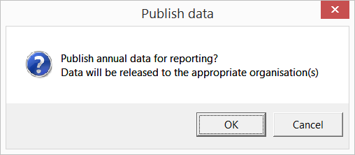

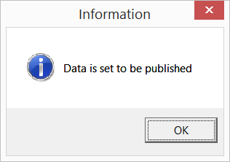

**Note** that if you change/correct any data after it has been set to ‘publish’ then your system will be automatically reset to ‘unpublished’ (the publish data button will go grey again and you will need to ‘publish’ the data again for it to become available to the requesting agencies). The SWIM contact for your organisation will receive an email to notify them that this has occurred.

1. In older versions of the software the way a user accessed data was setup during the initial install/login so that a particular computer could access all data for a particular scheme(s). This was only changeable by a user with a supervisor (or administrator) role. In the current version this is no longer the case and both supervisors and operators have essentially the same functionality.
2. System administrators must be assigned an ‘operations access group’ to be able to use the SWIM*Local* mobile data entry application. Administrators can always see everything in the SWIM*Local* tools (i.e. Admin, Operations, Annual Data and Reports tools), regardless of what groups they are assigned in relation to the mobile app.
3. Task users are controlled at the scheme level as task categories aren’t included in the access permissions. This is because they already have controlled access as you can only access task categories if you are assigned to handle tasks at a site (they can see all tasks at that site), so they bypass the access permissions.
4. Schemes are controlled via the SWIM*Local* Admin Tool.
5. **Note** that the background colour of calculated cells is half strength of the normal colour (i.e. lighter).